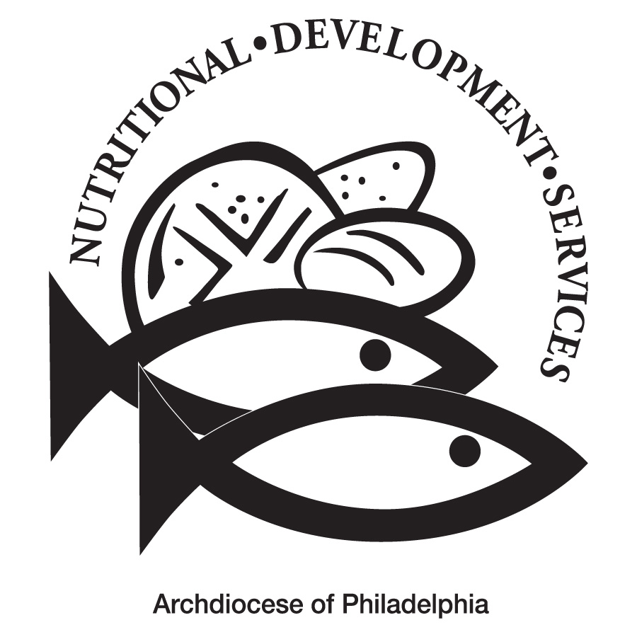
High School Breakfast
NDSSchoolLunchProgram
SchoolMealsNDS
SchoolMealsNDS

Nutritional Development Services–Archdiocese of Philadelphia
222 N 17th St, Philadelphia, PA 19103
215-895-3470, option 1
April 2024 333333333333333333333333333333333333333333333333

Menu is subject to change, a variety of low fat or skim milk is offered daily, condiments offered daily, fruit & vegetable juices are 100% juice, grains are whole grain rich, all items are pork-free.
Weekly Alternate | Monday | Tuesday | Wednesday | Thursday | Friday
382 Cinnamon Toast Crunch Cereal Bar Breakfast Kit  OR  316 Eggo Maple Pancakes | 1  304 Cinnamon Frosted Flakes  Cereal Cup  OR  239 Chicken Sausage & Cheese Waffle Sandwich HOT  445 Mott’s Fruit Punch Juice  657 Strawberry Craisins  Easter Monday | 2  311 Apple Jacks Cereal Pouch  & 136 Vanilla Yogurt  OR  336 Apple Churro  & 136 Vanilla Yogurt  649 Dole Orange Gello Cup  690 Apple Crisps | 3  350 Peach Cheerios Cereal Bar  OR  369 Pillsbury Berry Blast Mini French Toast  670 Fresh Fruit  608 Dole Tropical Fruit Cup | 4  318 Eggos Cinnamon Mini Waffles  OR  302 Egg, Cheese & Turkey Sausage Wrap  446 Mott’s Fruit Punch Juice  670 Fresh Fruit | 5  321 Banana Muffin  OR  328 Chocolate Chip Muffin  658 Cherry Craisins  697 Bagged Sliced Apples
387 Froot Loops Breakfast Kit  OR  318 Eggos Cinnamon Mini Waffles | 8  351 Cinnamon Toast Crunch Bar  OR  315 Apple Cinnamon Toast HOT  670 Fresh Fruit  649 Orange Gello Bowl | 9  319 Orange Cranberry Muffin  OR  133 Strawberry Banana Yogurt  & 922 Cinnamon Granola  445 Mott’s Fruit Punch Juice  691 Strawberry Apple Crisps | 10  367 Cinnamon Raisins Bagel  OR  306 Apple Baked Frudel HOT  670 Fresh Fruit  659 Watermelon Craisins  Eid-al-Fitr | 11  323 Apple Cinnamon Muffin  OR  310 Frosted Flakes Pouch  & 133 Strawberry Banana Yogurt  684 Mixed Berry Applesauce  670 Fresh Fruit | 12  329 Honey Cheerios Cereal Cup  OR  316 Eggo Maple Pancakes  670 Fresh Fruit  446 Mott’s Apple Juice
391 Blueberry Muffin Breakfast Kit  OR  323 Apple Cinnamon Muffin | 15  320 Corn Muffin  OR  312 Froot Loops Cereal Pouch  & 137 Peach Yogurt  670 Fresh Fruit  445 Mott’s Fruit Punch Juice | 16  324 Cocoa Puffs  OR  262 Turkey Sausage Breakfast Pizza HOT  670 Fresh Fruit  644 Dole Pear Cup | 17  303 Frosted Flakes Cereal Cup  OR  328 Chocolate Chip Muffin  670 Fresh Fruit  446 Mott’s Apple Juice | 18  327 Eggo Maple Waffles  OR  367 Cinnamon Raisin Bagel  670 Fresh Fruit  658 Cherry Craisins  National Banana Day | 19  321 Banana Muffin  OR  338 French Toast Sticks HOT  691 Strawberry Apple Crisps  670 Fresh Fruit
385 Trix Breakfast Kit  OR  324 Cocoa Puffs Cereal | 22  334 Cinnamon Toast Crunch Cereal OR  134 Cherry Vanilla Yogurt  & 921 Granola  670 Fresh Fruit  684 Mixed Berry Applesauce | 23  322 Blueberry Muffin  OR  369 Pillsbury Berry Blast Mini French Toast  446 Mott’s Apple Juice  684 Mixed Berry Applesauce | 24  317 Eggo Confetti Pancakes  OR  306 Apple Baked Frudel HOT  670 Fresh Fruit  659 Watermelon Craisins | 25  308 Strawberry Mini Bagel  OR  315 Apple Cinnamon Toast HOT  670 Fresh Fruit  445 Mott’s Fruit Punch Juice | 26  350 Peach Cheerios Cereal Bar  OR  323 Apple Cinnamon Muffin  670 Fresh Fruit  645 Dole Pineapple Cup

PLEASE READ CAREFULLY. Parents are strongly advised to review the menu completely to ensure that each of the food items are suitable for their children, and will not trigger an allergic reaction or related illness. The Archdiocese of Philadelphia, Nutritional Development Services, Inc. and your children’s school shall not be responsible for any allergic reaction or related illness caused by any food item. Upon request and without charge, Nutritional Development Services will provide parents with information on any food item, which has been provided by the supplier of the food item. To request product information please call (215) 895-3470 during normal business hours.

