A message from NUTRITIONAL DEVELOPMENT SERVICES
September 13, 2023: Wellness Wednesday
Try these interactive activities that will engage your students—they'll use their creativity and design skills

Try this hands-on activity that will have students using their creativity and design skills to:
- Create their own wellness journal to use throughout the school year to reflect on their daily wellness habits.
- Plan and consider their daily nutrition, meal choices, movement, and physical activity.
- Journal and reflect through self-awareness, recording how they are feeling as a result of their daily wellness habits.
Teachers: Get in on the fun and create a journal for yourself as well!

"Breathe Easy" this Back to School
Back to school is a busy, stressful time for families and school communities alike! Breathe easy with this interactive activity for you and your students to do together.

The activity focuses on breathwork and is ready for you to use in your classroom—you'll have your students breathing their way to calm, centered focus, so that they are ready to learn!

Have an Excellent Back-to-School Season!
The Fuel Up Team

A message from NUTRITIONAL DEVELOPMENT SERVICES
September 20, 2023: Wellness Wednesday

National School Lunch Week is Coming!
Greetings from NDS!
The National School Lunch Program (NSLP) serves nearly 30 million children every school day. President John F. Kennedy created National School Lunch Week (NSLW) in 1962 to promote the importance of a healthy school lunch in a child’s life and the impact it has inside and outside of the classroom.
NDS thanks the hundreds of dedicated staff and administrators at our partner schools who work hard every day. Their dedication ensures children can rely on them to have tasty meals ready for them at lunchtime.
#NSLW23 will be celebrated October 9-13, 2023.
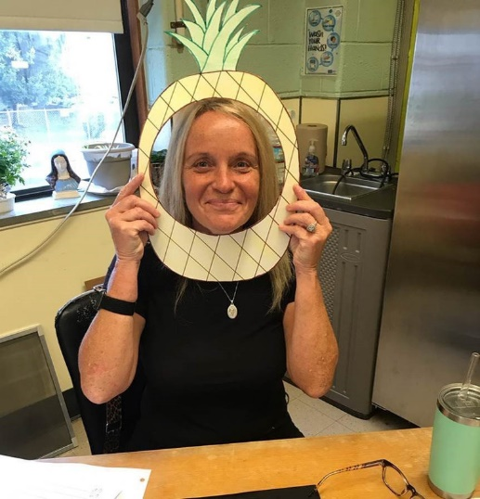
The National School Lunch Program:
Supporting Healthy, Well-Nourished Students
Balanced nutrition throughout the day contributes to student success in and out of the classroom. The National School Lunch Program (NSLP) offers students fruits, vegetables, whole grains, lean protein and fat free or low fat milk with every school lunch. Updated federal nutrition standards also ensure these meals are within age-appropriate calorie levels and limit both unhealthy fats and sodium.
Multiple studies show that NSLP plays an important role in supporting obesity prevention and overall student health by improving children’s diets and combatting food insecurity:
Children receiving school lunches consume fewer empty calories and more milk, fruit, vegetables and fiber than their peers - they are also more likely to have appropriate intakes of calcium, vitamin A and zinc.
School lunches are healthier than typical packed lunches - school lunches contained fewer calories, fat, saturated fat and sugar than lunches brought from home.
School lunch participation is associated with a lower body mass index (BMI) - school and child care meals help children maintain a healthy weight.
NSLP reduces food insecurity, which is linked to negative health, development and educational outcomes such as slower progress in math and reading and a higher likelihood of repeating a grade.
NSLP serves nearly 30 million students each school day in approximately 95,000 public and private schools nationwide.
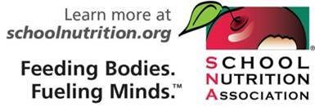
Key Sources:
Arteaga, Irma, and Colleen Heflin (2014). “Participation in the National School Lunch Program and food security: An analysis of transitions into kindergarten,” Children and Youth Services Review, 47 (2014): 224- 230.

Caruso, M.L. & Cullen, K.W. (2015). Quality and cost of student lunches brought from home. JAMA Pediatrics, 169(1), 86-90. doi:10.1001/jamapediatrics.2014.2220

Condon, E. M., Crepinsek, M. K., & Fox, M. K. (2009). School meals: types of foods offered to and consumed by children at lunch and breakfast. Journal of the American Dietetic Association, 109(2 Supplement 1), S67- S78.

Condon, Elizabeth, Susan Drilea, Carolyn Lichtenstein, James Mabli, Emily Madden, and Katherine Niland (2015). Diet Quality of American School Children by National School Lunch Participation Status: Data from the National Health and Nutrition Examination Survey, 2005– 2010. Project Officer: Jenny Laster Genser. Prepared by Walter R. McDonald & Associates, Inc. and Mathematica Policy Research for the U.S. Department of Agriculture, Food and Nutrition Service.

Cullen, K.W., and T.-A. Chen (2017). “The contribution of the USDA school breakfast and lunch program meals to student daily dietary intake,” Preventive Medicine Reports, 5:82-85.
Farris, Alisha R. et al. (2014). Nutritional comparison of packed and school lunches in pre-kindergarten and kindergarten children following the implementation of the 2012-2013 National School Lunch Program standards. Journal of Nutrition Education & Behavior, 46(6), 621-625. doi:10.1016/j.jneb.2014.07.007
Gundersen, C., Kreider, B., & Pepper, J. (2012). The impact of the National School Lunch Program on child health: a nonparametric bounds analysis. Journal of Econometrics, 166, 79–91.
Huang, Jin, and Ellen Barnidge (2016). Low-income children’s participation in the National School Lunch Program and household food insufficiency,” Social Science and Medicine, 150: 8-14.
Johnston, C.A., Moreno, J.P., El-Mubasher, A. & Woehler, D. (2012). School lunches and lunches brought from home: A comparative analysis. Childhood Obesity, 8(4), 364-367. doi:10.1089/chi.2012.0012

Kimbro, R. T., & Rigby, E. (2010). Federal food policy and childhood obesity: a solution or part of the problem? Health Affairs, 29(3), 411–418.

Ralston, Katherine, Katie Treen, Alisha Coleman-Jensen, and Joanne Guthrie (2017). Children’s Food Security and USDA Child Nutrition Programs, EIB-174, U.S. Department of Agriculture, Economic Research Service.

A message from NUTRITIONAL DEVELOPMENT SERVICES
September 27, 2023: Wellness Wednesday

Improving Sleep Health
Adjusting back to the school year after summer break requires focus on good quality sleep. Quality sleep includes sleep duration, timing, and restfulness. Sleep is essential for good performance at school, as well as physical and mental health more generally. Read on to find out more about why good sleep is so important, and how to ensure children have good sleep.
What is good sleep?
- Duration:
  - Children 3-5 should get 10-13 hours of sleep
  - Children 6-12 should get 9-12 hours
  - Children 13-18 should get 8-10 hours of sleep a night
- Timing: Getting children to bed early allows them to enter deeper stages of sleep, which are more restful, earlier in the night.
- Quality: Good sleep involves sleeping through the night without waking up.
Importance of Good Sleep
- Growth: Children primarily grow at night when the body release growth hormones during sleep.
- Mental Health: Adequate sleep reduces the incidence of mental health disorders.
- Cognitive development: Sleep is important for memory consolidation, learning, and problem solving, and kids who sleep more tend to do better in school.
- Physical health: Sleep allows the body to recover from physical activity and supports the immune system.
Tips for Better Sleep
- Develop a bedtime routine to do every night
- Make sure the bedroom is cool and dark
- Stop using electronic devices an hour before bed
- Read a book or story before bed
Additional Resources
Why is Sleep So Important (Texas Children’s Hospital): https://www.texaschildrens.org/blog/why-sleep-so-important#:~:text=Sleep%20is%20especially%20important%20for,have%20learned%20throughout%20the%20day.
The Importance of Sleep for Kids (Johns Hopkins): https://www.hopkinsallchildrens.org/ACH-News/General-News/The-importance-of-sleep-for-kids

