A message from NUTRITIONAL DEVELOPMENT SERVICES
7/19/2023: Wellness Wednesday
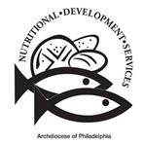
Summer Fruits and Vegetables
Summer is the perfect time to enjoy fruit and vegetable favorites, and to branch out to new and exciting options. Many fruits and vegetables are in season during the summer, ranging from corn and watermelon to blueberries and strawberries to eggplant and beets, among many more. Enjoying multiple servings of fruits and vegetables every day is a great way to improve health and maintain a nutritious diet. Learn more about serving sizes, encouraging picky eaters, and unique recipe ideas below.
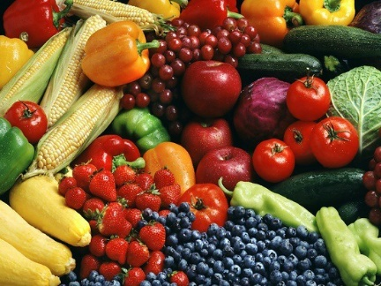
Fruit and vegetable basics
What does “one serving” mean? Servings of fruits and vegetables are usually measured in cups. For some examples, one cup is equivalent to one small apple, 12 grapes, one large banana, two large carrots, half a cucumber, or two handfuls of a dark leafy green.
Servings per day: Daily servings change based on age, ranging from about two cups a day for 1-2 year olds, up to four cups for 14-18 year olds. To keep things simple, make half your plate at each meal fruits and vegetables and include at least one fruit or vegetable snack a day.
Encouraging Picky Eaters
Getting kids to try new fruits and vegetables is no easy feat. Try some of these strategies to encourage them!
Increase familiarity: Giving kids an option of fruits and vegetables every day will increase their exposure and make them feel more comfortable with different fruit and vegetable options.
Explain the importance of fruits and vegetables: Some kids respond well to learning more about why fruits and vegetables are important, like how they contain essential nutrients we need for a healthy diet.
Be a good role model: Seeing adults eat their fruits and vegetables will motivate kids to do the same.
Add more flavor: Kids may enjoy fruits and vegetables more when extra flavor is added, like carrots with hummus, celery with nut butter, or salad with flavorful dressing.
Encourage kids in the kitchen: Allowing kids to contribute to cooking will motivate them to eat what they helped make. Try some of the recipe ideas below!
Unique ways to enjoy fruits and vegetables
Trying unique ways to mix fruits and vegetables can be a fun way to incorporate more into your diet. Try these recipes for a different spin!
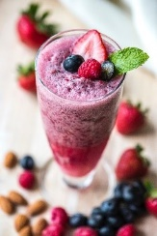
Sweet potato pasta sauce: In a blender, combine a boiled sweet potato, tomato, milk, and spices and blend into a smooth, creamy sauce. Add the sauce to pasta and enjoy with parmesan cheese.
Refreshing smoothie: In a blender, combine any fresh or frozen fruits with ice and blend until smooth. Try adding a nut butter, dark leafy greens, or nuts/seeds for a different flavor and more nutrients. Get creative with what you add!

Additional resources
Seasonal Produce Guide (USDA): https://snaped.fns.usda.gov/resources/nutrition-education-materials/seasonal-produce-guide
Getting Kids to Eat Veggies (Cleveland Clinic): https://health.clevelandclinic.org/how-to-get-kids-to-eat-veggies/
Full sweet potato pasta sauce recipe: https://www.foodandwine.com/recipes/sweet-potato-and-tomato-sauce

A message from NUTRITIONAL DEVELOPMENT SERVICES
Wellness Wednesday: 7/26/2023
Staying Active in the Summer
Staying active is one of the most fun ways to spend the summer months, and it is also one of the healthiest! Exercise can include everything from going for a run outside to playing basketball in the park to turning on music and having a dance party. Most importantly, exercise involves getting your heart pumping and your muscles active to move your body. Read on to learn about some of the benefits of exercise, ideas on how to get active, and some nutritional tips to make sure you fuel your exercise.

Benefits of exercise
Staying active and doing exercise has many health benefits. First, exercise is good for your heart. Regularly increasing your heart rate through exercise strengthens the heart muscle and is known to decrease the risk of cardiovascular disease. This can also improve weight loss and weight management.
Next, exercise can improve mental health. Exercise causes the release of feel-good hormones called endorphins in the brain. Endorphins make the body feel good and decrease the risk of anxiety and depression in children, all just by doing exercise!
Finally, exercise is a good way to avoid screen time. While relaxing in front of the screen can be a fun way to unwind over the summer, it is important to get up and move around in order to stay active. This is also known to improve sleep and focus, which will keep your mind sharp over the summer months.
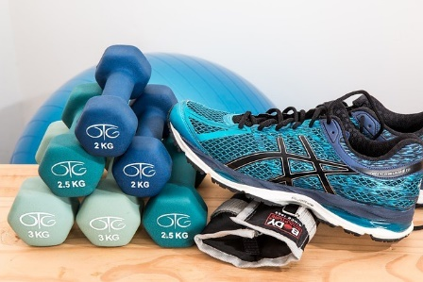

Exercise and activity ideas
There are many ways to get involved in exercise, especially over the summer. Try out some of these ideas:
- Join a team sport: exercising with a group will increase both motivation and fun. Check out Philadelphia Youth Sports Collective and Students Run Philly Style (linked below) for more information
- Set up a race or obstacle course: Time yourself and friends in a park or playground to complete an obstacle course.
- Go to a public pool or Sprayground: there are many public pools throughout Philadelphia and the counties which offer a great way to exercise while cooling off. Make sure to swim safely!
- Follow a workout video: turn on some music and find an online workout class to do at home or outside

Exercise and nutrition tips
Doing exercise and staying active requires focused nutrition in order to stay safe and energized.
- Fuel your body: eat enough to stay active, and make sure to have enough protein to replenish yourself
- Stay hydrated: spending time in the summer sun can be very tiring, so make sure to drink water and electrolytes to replace the sweat you lose

Additional resources
Benefits of Exercise (CDC): https://www.cdc.gov/physicalactivity/basics/pa-health/index.htm
Philadelphia (area) Youth Sports Collective: https://www.pysc.org/member-organizations/
Students Run Philly Style: https://studentsrunphilly.org/
