A message from NUTRITIONAL DEVELOPMENT SERVICES
Wellness Wednesday: 8/2/2023

Healthy Summer Hydration
The summer heat is still with us and it is important as ever to make sure we stay hydrated. Water is essential to the body to maintain a healthy temperature, to provide lubrication for moving body parts, and to move around nutrients and waste products. While we should take care to avoid dehydration, not all ways to hydrate are created equal. In general, stick to water for hydration as much as possible. Make sure water is easily available, especially at meal time. Follow the these to stay hydrated in a healthy way.

Hydration Tips
Drink when you get thirsty
You may have heard the 8 cups a day rule, or other numbers stating how much water to drink. A better rule to follow is to drink enough to prevent thirst. When you do get thirsty, answer your body’s call for more water with plain water rather than other sugary drinks. This recommendation may change based on your doctor’s instructions.
Keep a reusable water bottle
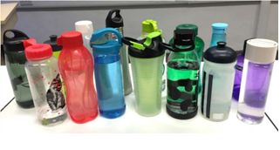
Keep a reusable bottle with you throughout the day for easy hydration. You’ll be able to keep water handy which will make it easier to stay hydrated. Having a reusable water bottle also reduces waste and is good for the environment. You can even fill your bottle up in the evening and leave it in the freezer overnight to have cold water all day.
Snack on hydrating foods
Hydration does not always mean drinking! Foods that contain lots of water, like watermelon, cucumber, lettuce, and tomato are great hydrating snacks. Enjoying these fresh fruits and vegetables provides plenty good nutrients too!
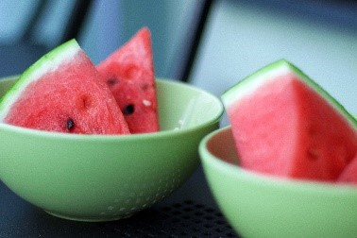
Beware of the signs of dehydration
Dehydration can happen to anyone, and can be dangerous. Symptoms of dehydration can include dizziness, headache, nausea, dark and infrequent urine, and a dry mouth. Hydration can help you avoid these symptoms and more.
Avoid sweet and sugary drinks
Drinking sugary drinks adds a large number of calories to your diet without adding much other nutritional value. While sweet drinks can be a treat from time to time, avoid drinking them as a way to stay hydrated.
Spice up your water
Add fruits and herbs like lemon or mint to add a touch of flavor to a simple glass of water. Or, if you’re craving carbonation, add a splash of fruit juice to a cup of sparkling water for a low-calorie fizzy drink.

Additional resources
Make better Beverage Choices (USDA): https://www.myplate.gov/tip-sheet/make-better-beverage-choices
Rethink Your Drink (CDC): https://www.cdc.gov/healthyweight/healthy_eating/drinks.html
Benefits of Drinking Water (CDC): https://www.cdc.gov/healthyweight/healthy_eating/water-and-healthier-drinks.html

A message from NUTRITIONAL DEVELOPMENT SERVICES
August 23, 2023: Wellness Wednesday

Mindful Eating
Greetings from NDS!
The idea of Mindfulness as a practice to become calm and connected with the world around us traces back to Zen Buddhism (1). Mindful eating applies the idea of mindfulness to the way we eat. Mindful eating highlights the differences between hunger and appetite. Hunger is a physical state where the body needs food for fuel, while appetite is a mental state based on the desire to eat. Practicing mindful eating can have many benefits both mentally and physically, and is easy to apply to everyday life.

What elements of this philosophy can be added to meal service at your school or center?

Ideas behind mindful eating
- We know when we are hungry and when we are full: Our minds and bodies know when to start and stop eating. If we connect with these internal signals, we will eat more healthfully and provide what the body needs.
- Food is fuel: Remember that what we eat is the food our bodies use for energy. This doesn’t mean that food shouldn’t be enjoyed, but it is important to be aware that the body can only use the food we give it.
- Increasing gratitude: We are fortunate to have meals to eat, regardless of their source, and it is important to be grateful for what we have.
Benefits of mindful eating
- Greater connection with the body: Eating mindfully allows the mind to connect with physical sensations of the body, giving us greater control over our hunger and fullness.
- Greater connection with the food: Being present and aware while eating allows us to connect with the food we have to eat in relation to its quality, taste, and source.
How to practice mindful eating
- Focus on the meal: Put away distractions like screens, and take the time to just eat. Be present at the table and make the meal your priority.
- Focus on sensations: As you eat, think about taste, feeling, and how full you are getting. Be aware of each bite you take and have a purpose for your actions as you eat.
- Provide enough time to savor and enjoy food: savor small bites, chew thoroughly, and eat slowly.
- Think about what you learned: After a mindful meal, take the lessons you learned while present to apply to other meals.
Additional resources
- Mindful Eating (Harvard): https://www.hsph.harvard.edu/nutritionsource/mindful-eating/
- What is Mindful Eating (Cleveland Clinic): https://health.clevelandclinic.org/mindful-eating/
Sources
- Mindful Eating: The Art of Presence While you Eat: https://www.ncbi.nlm.nih.gov/pmc/articles/PMC5556586/

A message from NUTRITIONAL DEVELOPMENT SERVICES
August 30, 2023: Wellness Wednesday

Food Safety in the Classroom
Greetings from NDS!
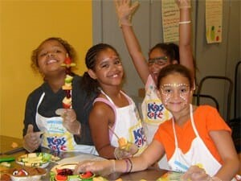
September is National Food Safety Education Month! With the new school year beginning, we want to make sure we keep kids healthy and safe by protecting them from foodborne illnesses.
Below are three simple ideas for adding food safety into your activities with kids this month and throughout the whole year:
1. Experiment
Turn your classroom into a “food safety science lab”. Inspire children to learn the science behind food safety as they experiment, investigate and explore!
Fighting Bac! has created curriculum and programs to incorporate in the classroom setting, grades K through 12 grade. Included are experiments, activities, discussion topics, handouts, and take home messages. To access, click here.
2. Pair nutrition
Nutrition and food safety go hand-in-hand in keeping kids healthy! Be sure to incorporate food safety in your nutrition education topics. Looking for ideas? These placemats, activity sheets, and coloring pages make it easy and fun for kids to learn food safety! If you are looking for additional support in providing nutrition education, NDS has several interns throughout the school year who can assist. If interested, contact Jean Falk at jfalk@ndsarch.org.
3. Building Recipes
Cooking and building safe recipes incorporates math, science, nutrition, and food safety in a real-life setting that allows students to explore their creativity. Encourage your students to create safe and healthy recipes and to share with classmates.
*Resources
- Inspire young cooks
- Safe Recipes
- Safe Recipe Activity

